Project Activity Report-1

Project Title: “Build a GNU/Linux Distribution”

Team members: Faculty Guide:

Arpan Chavda (09bce006) Dr. Sanjay Garg

Hitesh Piprotar (09bce054) Computer Sci. & Engg. Department



Duration: 7/1/2013 to 22/1/2013

* We are developing two Linux distributions.

1) DMLinux

2) Open Gujarat

* DMLinux stands for developers’ mono Linux. It is developed for students, coders, software engineers, developers which help them in their everyday work.
* OpenGujarat is for the students of entire Gujarat state. It is completely in regional language.

**Requirement Analysis**

* We are developing this two linux distribution at user level.We are not developing this at kernel level.
* For this we are analyzing system at user level.All stuff at kernel level is proivded inside Ubuntu's precompiled kernel edition.

**Desktop Environment Analysis**

* There are five famous desktop environments in Linux world.Each have its own unique perpose for development.
  + KDE
    - Widgets support, High Animation
    - More functionality
    - Higher RAM usage after clean boot : Aprrox. 450 MB
    - Default UI in this OS : Kubuntu,Rosa Linux,Chakra OS
  + GNOME Shell 3.6
    - Compact look
    - Calendar integration,Desktop search support
    - Less RAM usage after clean boot : Approx. 230MB
    - Default UI in this OS : Fedora,Pinguy OS
  + UNITY UI
    - Modern look
    - Web Apps support,Shopping search support
    - No support for low end graphics devices
    - Default UI : Ubuntu,Edubuntu,Ubuntu server edition
  + XFCE
    - Compact and very easy to use
    - RAM usage after clean boot : Approx. 160 MB
    - Highly customization support
    - Default UI in this OS: Xubuntu,Mint XFCE edition
  + LXDE
    - Known as lightweight desktop environment in Linux world.
    - RAM usage after clean boot : Approx. 120MB
    - Less functionality and less customization support
    - Default UI : Lubuntu,Mint and Puppy Linux

**Linux OS and system files**

* We tested different GNU/Linux Operating system to understand how it works and which system files are doing what.
* Following neat diagram explains about Linux OS system files.

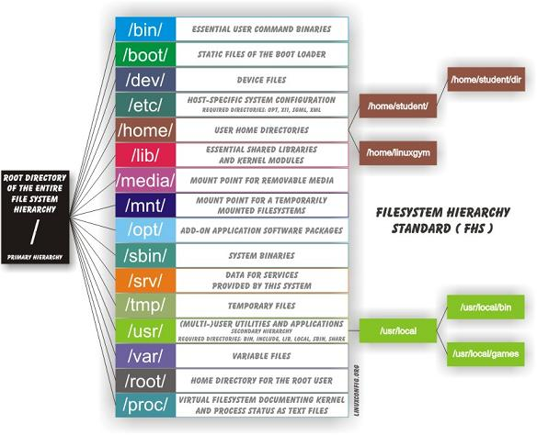

**Minimal Disk Development**

* In this, We are going to integrate system utilites and make minimal ISO from following links.
  + <https://help.ubuntu.com/community/Installation/MinimalCD>
  + <https://help.ubuntu.com/community/LiveCDCustomization>

**Links**

* We have hosted both projects at following links.
  + DMLinux(<https://github.com/codejar-lab/dmlinux>)
  + OpenGujarat(<https://github.com/codejar-lab/opengujarat>)
  + Other applications repository(<http://github.com/codejar-lab>)